# The Water Cycle

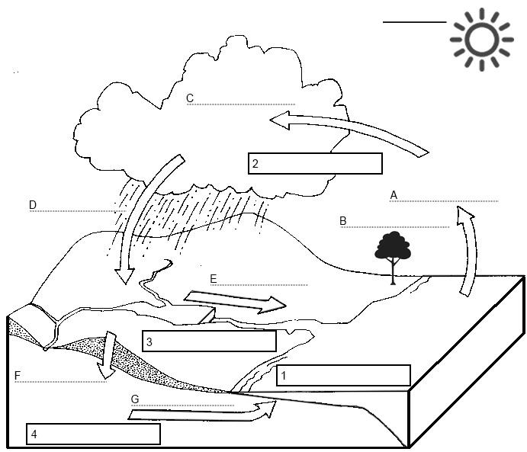

**Stages of the Water Cycle (P.E.R.T.I.C)**

|  |  |
| --- | --- |
| 1. Evaporation |  |
|  | The release of water vapour from plants and soil into the air |
|  | The transformation of water vapour to **liquid** water droplets in the air, creating clouds and fog |
| 1. Precipitation |  |
|  | The ways by which water moves across the land – rivers and streams |
|  |  |
|  | The flow of water underground |

Condensation Runoff Precipitation

Evaporation Infiltration Transpiration

1. **Which of the following is a renewable resource?**
   1. Coal
   2. Natural Gas
   3. Wind
   4. Oil
2. **Which of the following is the part of the water cycle when water is heated and turns to water vapour?**
   1. Evaporation
   2. Condensation
   3. Precipitation
3. **What are the three forms of water?**
   1. Precipitation, condensation, transpiration
   2. Liquid, solid, gas
   3. Black, green, grey
4. **What does the ‘I’ in PERTIC stand for?**
   1. Infiltration,
   2. Inspiration
   3. Interconnection
5. **Which of the following is the best definition of evaporation?**

a. It is the process of changing from gas to liquid

b. It is the process of changing from liquid to gas

1. It is the process of changing from gas to solid

1. **The two types of environments are ________ and human.**
   1. Cultural
   2. Political
   3. Physical

1. **Where does the energy that powers the water cycle come from?**
   * + 1. The sun
       2. Wind
       3. Electrical outlets

1. **Water which is released by plants in the water cycle is called:**
   1. Evaporation
   2. Condensation
   3. Transpiration
2. **Which type of water scarcity happens when there is not enough rainfall:**
   1. Economical
   2. Physical
   3. African

1. **What do the two S’s in SPICESS stand for?**
   1. Sustainability, Spice
   2. Space, Social
   3. Space, Sustainability

1. **What is an ‘environmental resource’?**
   1. A rock or tree that can be made into something
   2. The way that water circulates throughout the world
   3. Any material that we use from the environment, such as sunlight or coal.

1. **Wind energy and solar energy are examples of:**
   1. Renewable resources
   2. Non-renewable resources
   3. Continuous resources

1. **Which of the following is the best definition of ‘water scarcity’?**
   1. The lack of sufficient fresh water resources to meet the demand. Can be caused by physical or economic reasons.
   2. When water is misused by people in domestic or industrial settings
   3. The continuous cycle of water

**18. Define** what a renewable resource is and provide **three examples** to support your answer.  
______________________________________________________________________________________________________________________________________________________________________________________________________________________________________________________________________________

19**. List** the geographical concepts (SPICESS)

S P

I C

E S

S

20. Choose one of the SPICESS & provide a **definition**. Use an example to support your answer: _________________________________________________________________________________________________________________________________________________________________________________________________________________________________

21. **Differentiate** between renewable and non-renewable resources.

\**Differentiate means to state the differences between the two. Use words like ‘whereas’, ‘however’*

____________________________________________________________________________________________________________________________________________________________________________________________________________________________________________________________________________________________________________

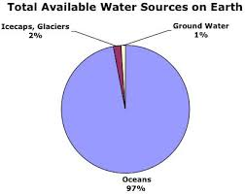21. **State** what percentage of the world’s water is located in Icecaps and Glaciers;

____________________________

22. **Calculate** the combined percentage of water located in icecaps, glaciers and ground water.

____________________________

‘

1. Create a **climate graph** for Kununurra on the grid below, using the temperature and precipitation data provided. Make sure to **label** your graph correctly. (8 marks)

|  |  |  |  |  |  |  |  |  |  |  |  |  |
| --- | --- | --- | --- | --- | --- | --- | --- | --- | --- | --- | --- | --- |
|  | **Jan** | **Feb** | **Mar** | **Apr** | **May** | **Jun** | **Jul** | **Aug** | **Sept** | **Oct** | **Nov** | **Dec** |
| **Average Temperature (°C))** | 31 | 30 | 30 | 28 | 26 | 23 | 22 | 24 | 28 | 31 | 32 | 32 |
| **Precipitation (mm)** | 209 | 217 | 142 | 30 | 7 | 3 | 1 | 0 | 4 | 22 | 59 | 139 |

**Source:** Bureau of Meteorology, 2020

|  |  |  |  |  |  |  |  |  |  |  |  |  |  |
| --- | --- | --- | --- | --- | --- | --- | --- | --- | --- | --- | --- | --- | --- |
|  |  |  |  |  |  |  |  |  |  |  |  |  |  |
|  |  |  |  |  |  |  |  |  |  |  |  |  |  |
|  |  |  |  |  |  |  |  |  |  |  |  |  |  |
|  |  |  |  |  |  |  |  |  |  |  |  |  |  |
|  |  |  |  |  |  |  |  |  |  |  |  |  |  |
|  |  |  |  |  |  |  |  |  |  |  |  |  |  |
|  |  |  |  |  |  |  |  |  |  |  |  |  |  |
|  |  |  |  |  |  |  |  |  |  |  |  |  |  |
|  |  |  |  |  |  |  |  |  |  |  |  |  |  |
|  |  |  |  |  |  |  |  |  |  |  |  |  |  |
|  |  |  |  |  |  |  |  |  |  |  |  |  |  |
|  |  |  |  |  |  |  |  |  |  |  |  |  |  |
|  |  |  |  |  |  |  |  |  |  |  |  |  |  |
|  |  |  |  |  |  |  |  |  |  |  |  |  |  |
|  |  |  |  |  |  |  |  |  |  |  |  |  |  |
|  |  |  |  |  |  |  |  |  |  |  |  |  |  |
|  |  |  |  |  |  |  |  |  |  |  |  |  |  |
|  |  |  |  |  |  |  |  |  |  |  |  |  |  |